E710 UHF EVEN READER Network Parameter Setting Description
- Power on the device and connect the network cable；
- Open software；
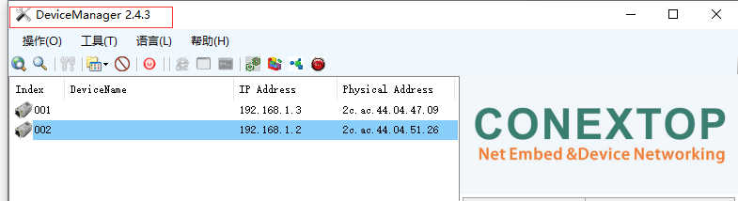
- Click Search；
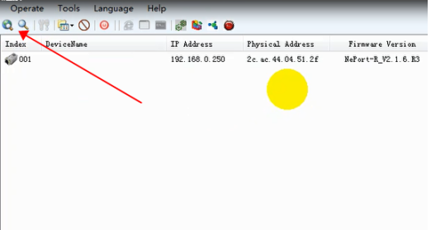
- Double click the device IP you want to modify, enter the user name: admin, password: admin, and click "Login" to enter the settings interface;
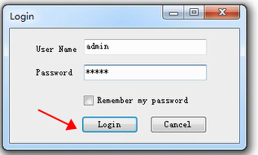

- Select Network to set IP, subnet code, and gateway. The IP address must be in the same network segment as the connecting device to connect to the network (default IP: 192.168.1.200);For example, if the IP of the computer is 192.168.1.11, the default gateway is 162.168.1.1. The IP of the device is 192.168.1.2-192.168.1.255 (not conflicting with other devices in the local area network). The subnet code is 255.255.255.0
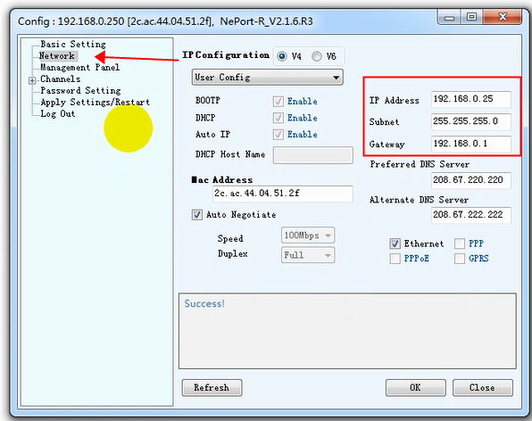

6.Set the baud rate, select Serial Settin-1 to modify the baud rate to be consistent with the device baud rate, and click OK;
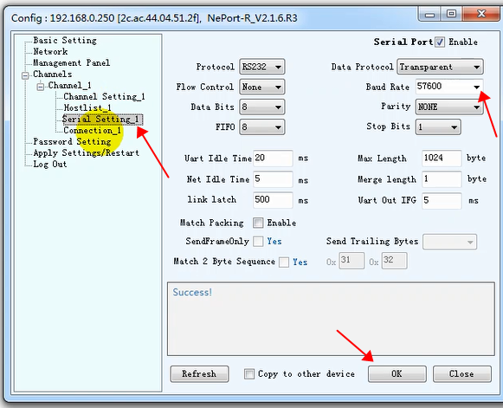

7.Set the local port number ();
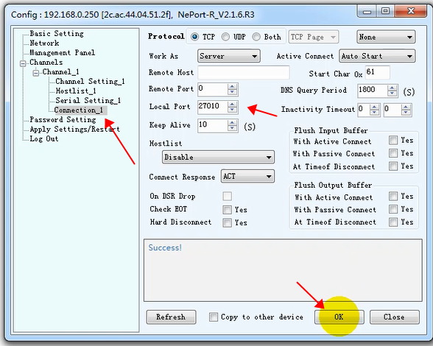
- Save the parameters and restart, click Apply Settings/Restart to select the saved parameters and restart, then click OK to return the software to success
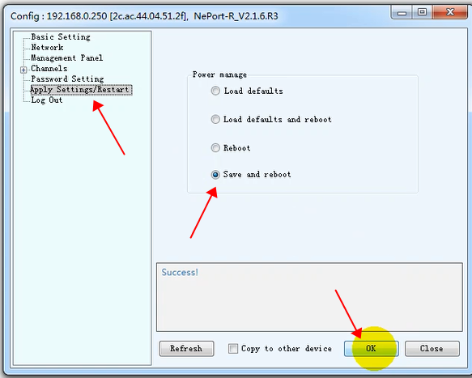
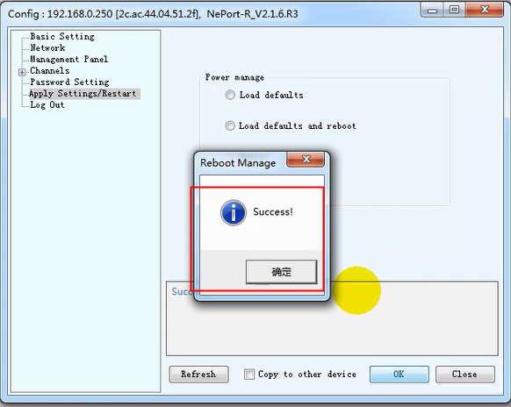

- Open the UHFReader288 Demo V5.0 Enter the IP address and port number just modified to connect the device;
